ELECTROMAGNETIC FIELDS REPORT
A Study involving RLC Circuit

Fall 2025
Name | Student ID
Anthony Ehab Edward | 2400313
Pierre Bahaa Maxi Habib | 2400106
Youssef Hisham Abdelkader | 2400937
Marwan Yasser Negm | 2400556
Ahmed Gamal Roushdy | 2400315
Amr Khaled Sedik | 2400476
Ahmed Mohamed Abd El Aziz | 2400293
Amr Khaled Ibrahim | 2400549
Ali Sabry Ebraheem | 2400546
submitted to
Prof. DR. Naggar Hassan
Prof. DR. Adel Abdel Monem
Ain Shams University – Cairo, Egypt
Academic Year 2025 / 2026

Contents
1.Introduction 1
2. Project Specifications 2
1.1 Inductor: 2
1.2 Capacitor: 2
1.3 Resistor: 2
1.4 Transformer: 2
1.5 Circuit Type: 2
1.6 Supply Type: 2
3. Theoretical design of the capacitor 2
4.Inductor design 3
3.1 Working Principle 3
3.2 Calculating The Inductance 4
3.3 Inductor Specs: 4
5.simulation of RLC Circuit 5
6. Conclusion 6

1.Introduction
Electrical and electronic circuits are fundamental components of modern engineering systems, as they are used in a wide range of applications such as power systems, communication devices, and control systems. The behavior of these circuits depends on the characteristics of their components and the way they interact with electrical signals. A solid understanding of basic circuit elements is therefore essential for analyzing and designing reliable electronic systems.

Resistors, inductors, and capacitors are the primary passive components used in circuit design. A resistor controls the flow of current and dissipates electrical energy in the form of heat, while an inductor and a capacitor store energy in magnetic and electric fields, respectively. Each component responds differently to changes in voltage and current, especially when alternating signals are applied. This frequency-dependent behavior plays an important role in determining the overall performance of electrical circuits.

When these components are combined in a single circuit, their interaction produces more complex electrical behavior. The total impedance of the circuit varies with frequency, affecting the magnitude and phase of the current. Analyzing such circuits allows engineers to predict voltage and current relationships and evaluate circuit performance under different operating conditions. This analysis is crucial in many practical applications where stable and predictable operation is required.

This report presents a detailed theoretical and practical study of circuits containing resistive, inductive, and capacitive elements. The fundamental principles governing each component are discussed, followed by an analysis of their combined behavior in an RLC circuit. Calculations and simulations are used to support the theoretical analysis and to demonstrate the validity of the results obtained.

2. Project Specifications

1.1 Inductor:
Designed and constructed inductor with an inductance of 1 mH.
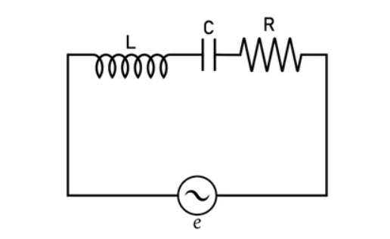Fig (1) RLC circuit

1.2 Capacitor:
28 µF film capacitor, with a theoretical design
based on electromagnetic field principles.

1.3 Resistor:
100 Ω, 5 W resistor.

1.4 Transformer:
220/24 V AC transformer with a current rating of 2 A.
1.5 Circuit Type:
Series RLC circuit powered by an AC source.

1.6 Supply Type:
Alternating Current (AC)

3. Theoretical design of the capacitor
A capacitor is an electrical component used to store energy in the form of an electric field between two conductive plates separated by an insulating material known as a dielectric. When a voltage is applied across the plates, electric charges accumulate, creating an electric field that stores electrical energy.
The capacitance of a capacitor depends on the geometry of the plates and the properties of the dielectric material. For a parallel-plate capacitor, the capacitance is given by:
$$C =\frac{ ε A}{d} ,Q=CV$$

In this project, a film capacitor with a capacitance of 28 µF is used. Film capacitors are preferred in AC applications due to their good stability, low dielectric losses, and high reliability. The dielectric material typically has a relative permittivity greater than unity, allowing a higher capacitance to be achieved without excessively increasing the plate area.
The theoretical design of the capacitor is based on selecting an appropriate dielectric material and adjusting the plate area and separation distance to achieve the required capacitance value. By increasing the plate area or using a dielectric with higher permittivity, the capacitance increases, while increasing the separation distance decreases the capacitance. This theoretical analysis demonstrates how electromagnetic field principles govern the behavior and design of practical capacitors used in RLC circuits.

4.Inductor design

3.1 Working Principle
An inductor operates on the principle of electromagnetic induction. When an electric current flows through a coil, it produces a magnetic field around the conductor. Any change in the current causes a corresponding change in the magnetic field, which in turn induces an electromotive force (emf) in the coil that opposes the change in current, according to Lenz’s law.
This opposing induced voltage is proportional to the rate of change of current and is given by:
$v\left(t\right)=L\frac{dI}{dt}$ where L is the inductance
As a result, an inductor resists sudden changes in current. In direct current (DC) circuits, the inductor initially opposes the current when the circuit is energized, but after reaching steady state, it behaves like a short circuit. In alternating current (AC) circuits, the inductor continuously opposes changes in current, st1oring energy in its magnetic field during one part of the cycle and releasing it during another.
The energy stored in an inductor is expressed as:
$$W=\frac{1}{2}LI^{2}$$

3.2 Calculating The Inductance
The required number of turns was calculated using the inductance equation based on the chosen core dimensions. The coil was then wound uniformly around the core to ensure a stable magnetic field distribution. After construction, the inductance value was measured using an LCR meter and compared with the theoretical value. Any deviation between the theoretical and measured inductance values can be attributed to practical factors such as imperfect winding, air gaps, and parasitic resistance. Despite these limitations, the constructed inductor achieved an inductance value close to the desired 1 mH, making it suitable for use in the series RLC circuit.
Using this formula: $L=μ\frac{N^{2}A}{l}$
Any deviation between the theoretical and measured inductance values can be attributed to practical factors such as imperfect winding, air gaps, and parasitic resistance. Despite these limitations, the constructed inductor achieved an inductance value close to the desired 1 mH, making it suitable for use in the series RLC circuit.

3.3 Inductor Specs:
Length: 33 cm
Number of turns : 283
Relative Permeability : 1
Cross section radius : 3.25 cm


This is the calculated theoretical via the formula above
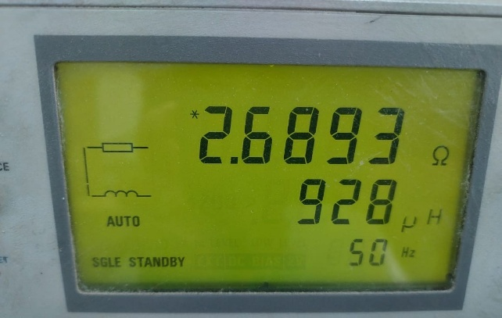
But this considers the solenoid to be ideal (infinitely long ) but through experiment and simulation this was measured inductance
And the error is 7% between the theoretical
calculations and The real inductance in the lab.

5.simulation of RLC Circuit
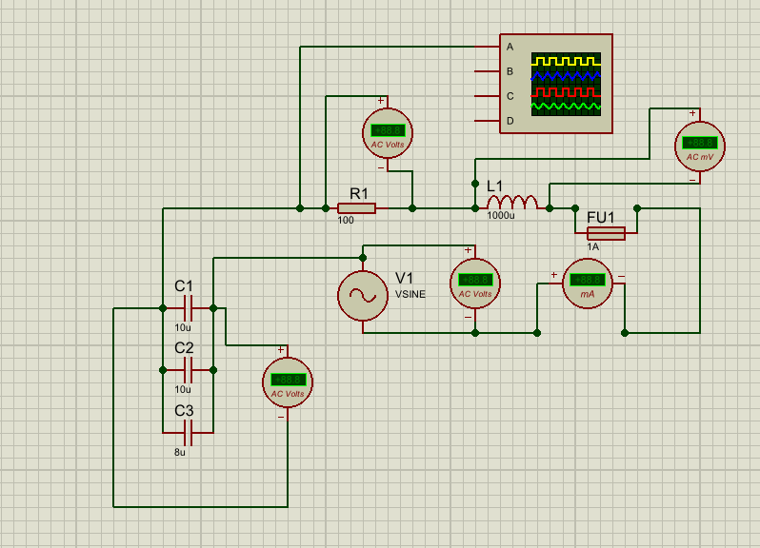
I=160mA
Voltage of capacitor=19.9v
Voltage of inductor=43.8mv
Voltage of resistance=13.7v

6. Conclusion
In this project, the RLC circuit was analyzed to study its electrical behavior under different operating conditions. The theoretical analysis explained how the resistance, inductance, and capacitance affect the total impedance, current, and phase angle of the circuit. The relationship between voltage, current, and frequency was examined based on the combined effect of the three components.

The results obtained from calculations and simulation showed consistent behavior with theoretical expectations, with small variations due to component tolerances and non-ideal characteristics. The RLC circuit demonstrates how energy is dissipated in the resistor and stored in the inductor and capacitor, making it an important circuit for understanding frequency-dependent behavior in electrical systems.

